# Project Introduction

Fossil fuel use is that the primary supply of carbonic acid gas. carbonic acid gas also can be emitted from direct human-induced impacts on biology and different land use, like through deforestation, land clearing for agriculture, and degradation of soils. Likewise, land also can take away carbonic acid gas from the atmosphere through rehabilitation, improvement of soils, and different activities.

Global carbon emissions from fossil fuels have considerably inflated since 1900. Since 1970, carbonic acid gas emissions have inflated by concerning ninetieth, with emissions from fuel combustion and industrial processes contributive concerning seventy eight of the overall greenhouse emission emissions increase from 1970 to 2011. Agriculture, deforestation, and different land-use changes are the second-largest contributors.

# Analysis OBjectives

Here are the list of question whose analysis which be given below.

1. Data Analysis using statistical methods.
2. Data Analysis using conditional filtering when Country is Saudi Arabia.
3. Data Analysis using conditional filtering when Year is 2014.
4. Data Analysis by grouping the data on the basis of Country.
5. Data Analysis using sorting the data in ascending/descending order.
6. Data Analysis after sorting the data on the basis of Total, filtering ony Saudi Arabia and group by on their Year.
7. Data Analysis after sorting the data on the basis of Total, filtering ony 2014 data and group by on the Country.
8. Visualize data of 2014 on the basis of Country using a chart with proper headings and legends.
9. Visualize data of Saudi Arabia on the basis of Year using a chart with proper headings and legends.
10. Visualize data of USA on the basis of Year using a chart with proper headings and legends.

# Data Acquisition and Cleaning

**Code to read the data from Excel / CSV / HTML.**

To read the dataset in xlsx format, we will load it into Pandas data frame but first let’s import the pandas library and set an alias by typing **“import pandas as pd”**. After importing the library with the alias **“pd”**, let us load the .csv file using the following line of code:

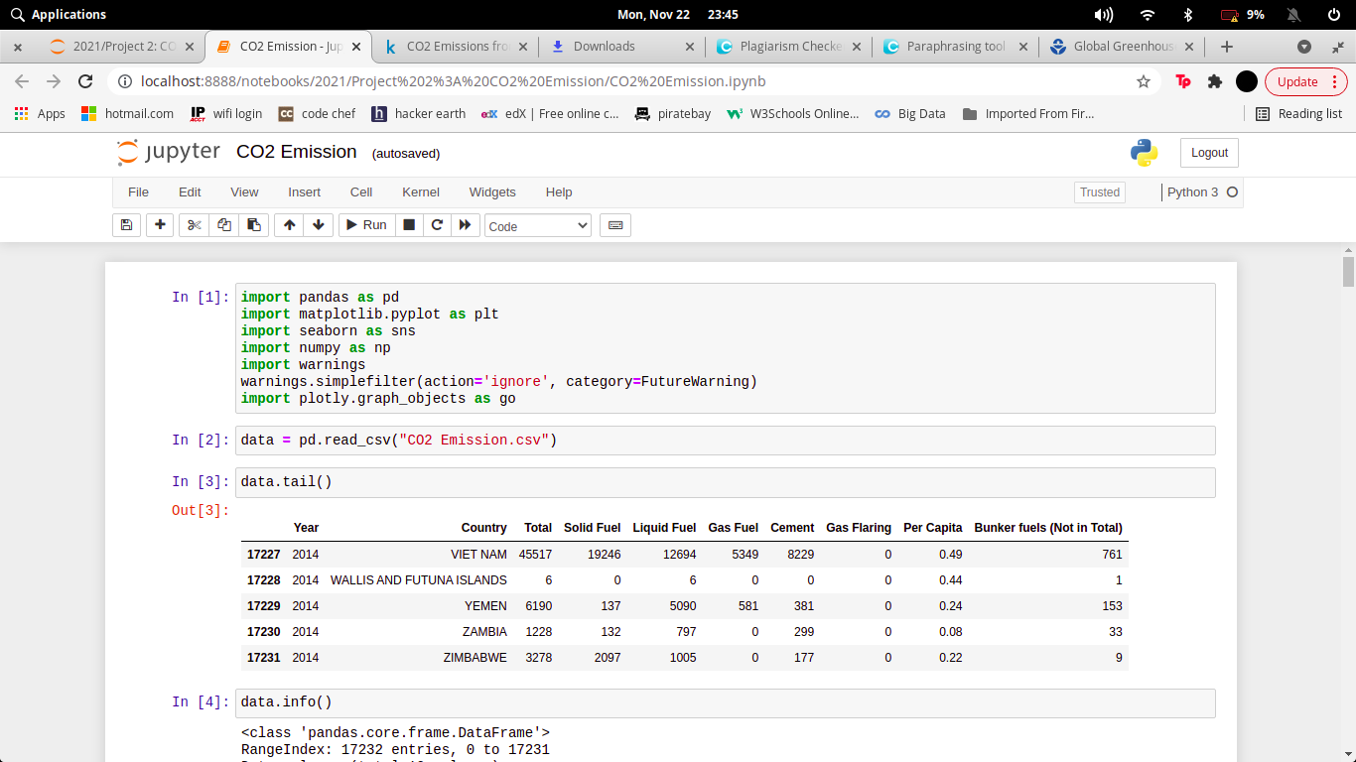

Here we have import our csv files and read through pandas library.

Here the xlsx file can be read through (Pandas library) and store in **data Dataframe**. The Dataframe can be shown through **.tail()**. The number of rows we want to show, that number we have to pass in head parentheses as an argument.

Now if we want to describe our dataframe for our better understanding to know the stats. and other parameter that our dataset should follow

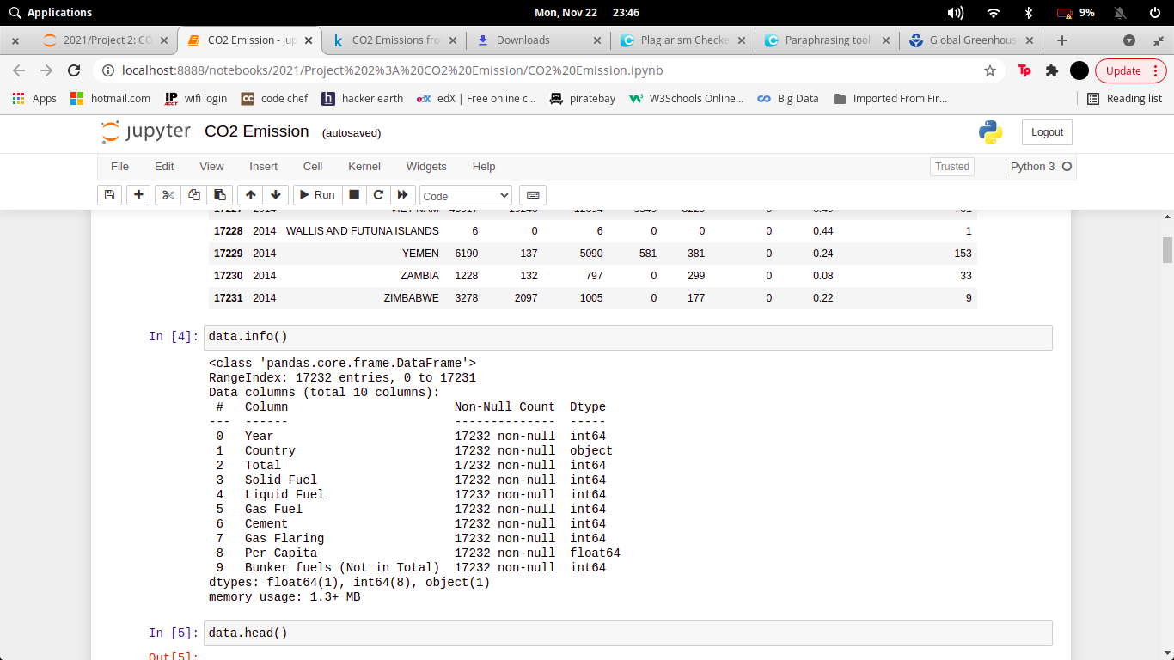

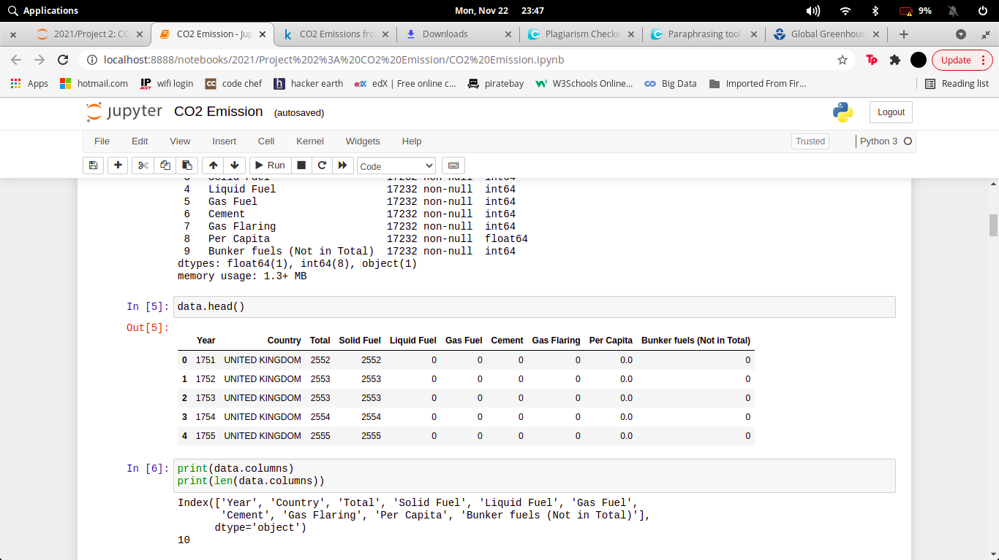

**Clean the unnecessary data, by removing, replace the missing data and renaming the columns.**

Dataset generally contains some null value, which is generally caused by misplacing some values. So its necessary to clean this mess from our dataset for better visualization

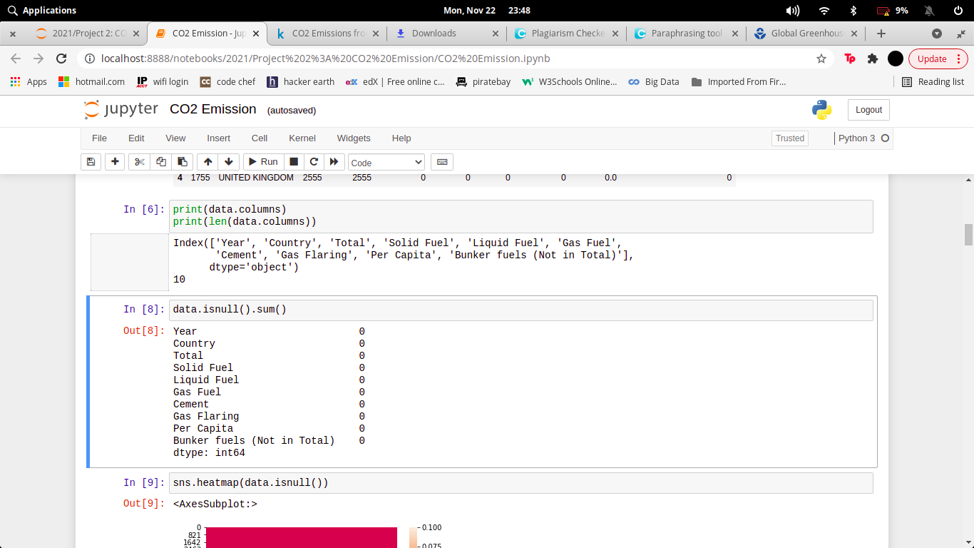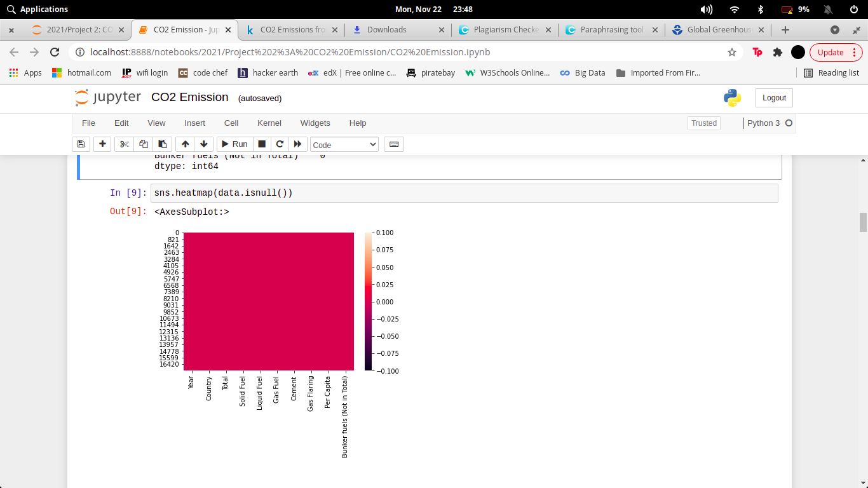

In the above diagram we see there is no columns of this dataset containing null value.

# Data and Exploratory Analysis

**Code and its output with Explanation**

1. **Data Analysis using statistical methods.**

This data gives the estimated amount to various statistical methods that can be applied.

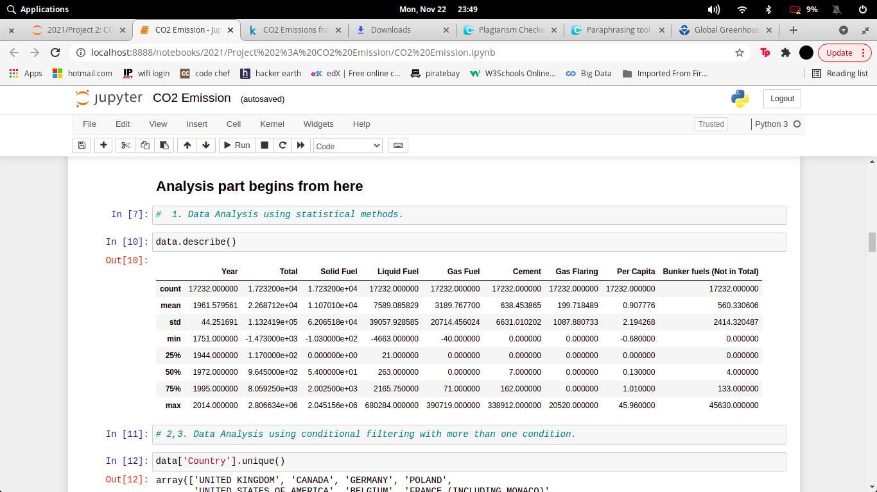

1. **Data Analysis using conditional filtering when Country is Saudi Arabia.**

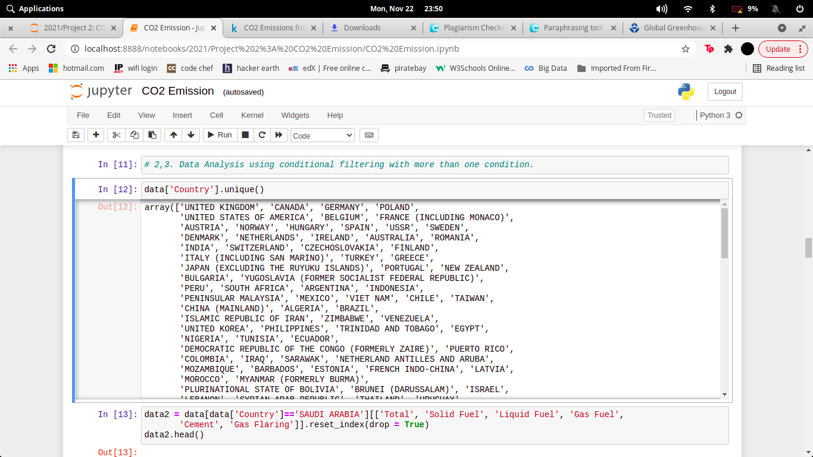

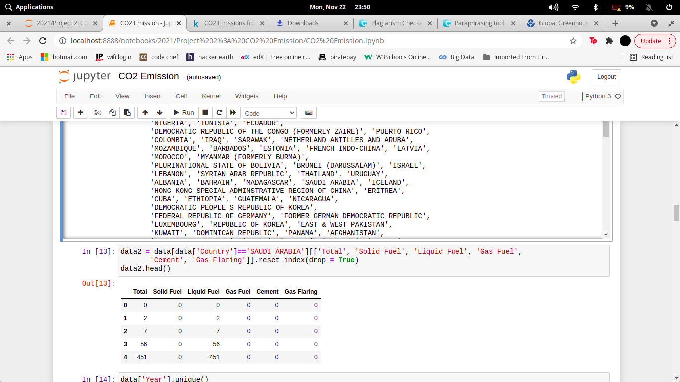

1. **Data Analysis using conditional filtering when Year is 2014.**

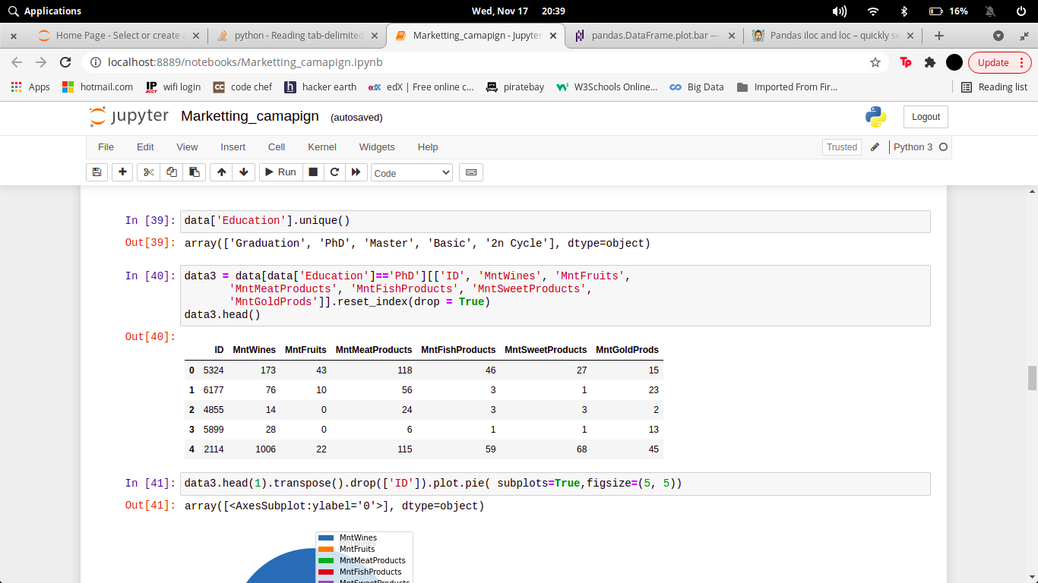

1. **Data Analysis by grouping the data on the basis of Country.**

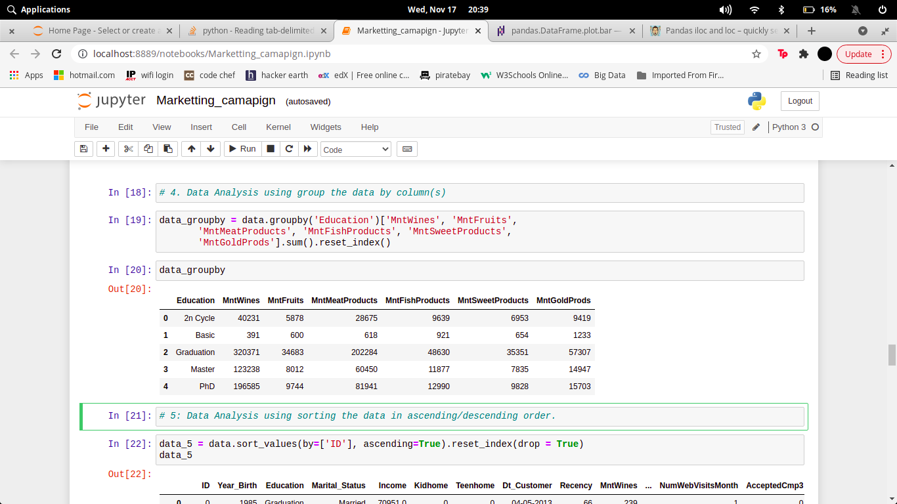

1. **Data Analysis using sorting the data in ascending/descending order.**

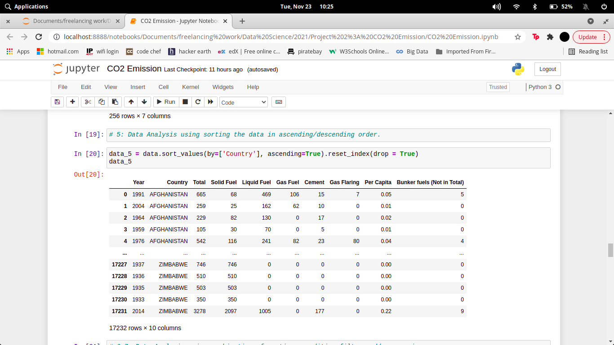

1. **Data Analysis after sorting the data on the basis of Total, filtering ony Saudi Arabia and group by on their Year.**

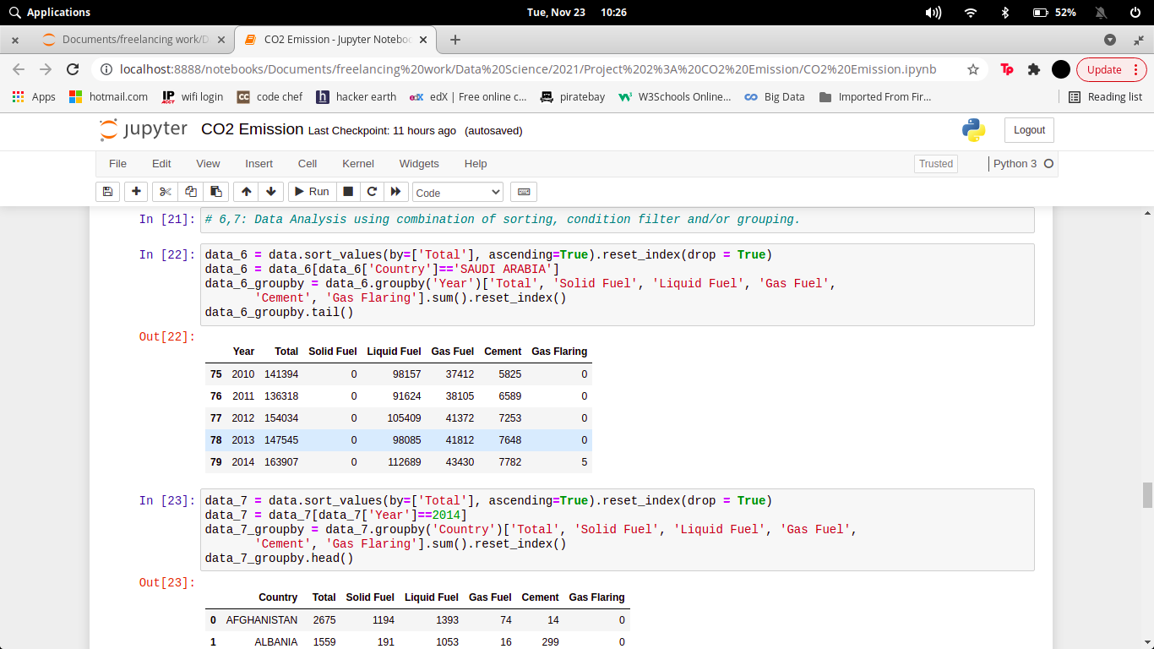

1. **Data Analysis after sorting the data on the basis of Total, filtering ony 2014 data and group by on the Country.**

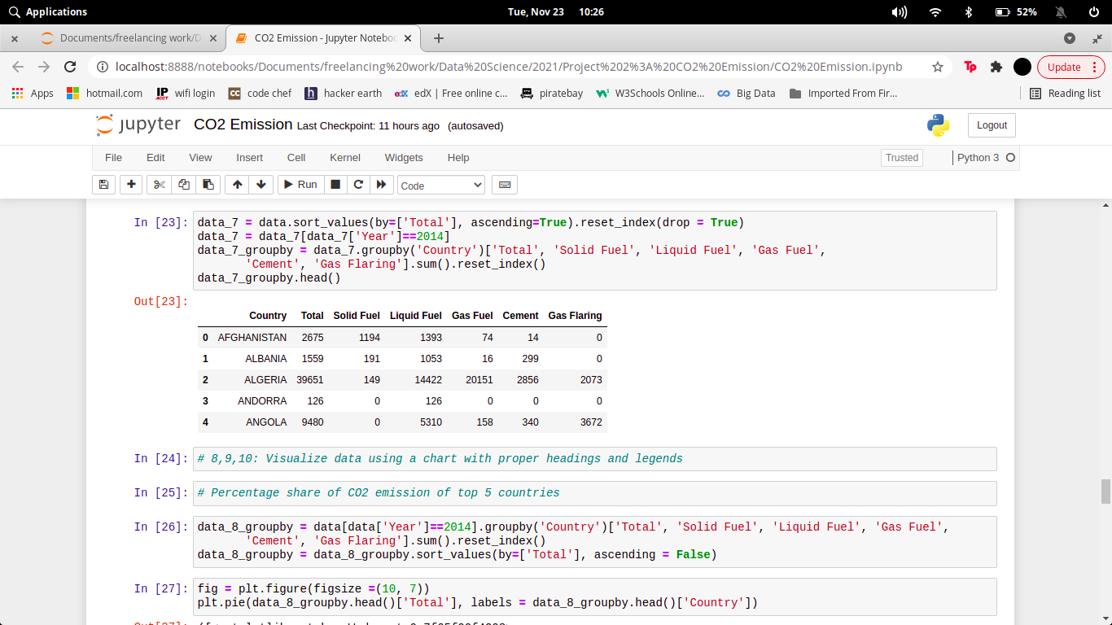

# Data Analysis – Visualization

**Code and its output with vizualization**

1. **Visualize data of 2014 on the basis of Country using a chart with proper headings and legends.**

**Code:-**

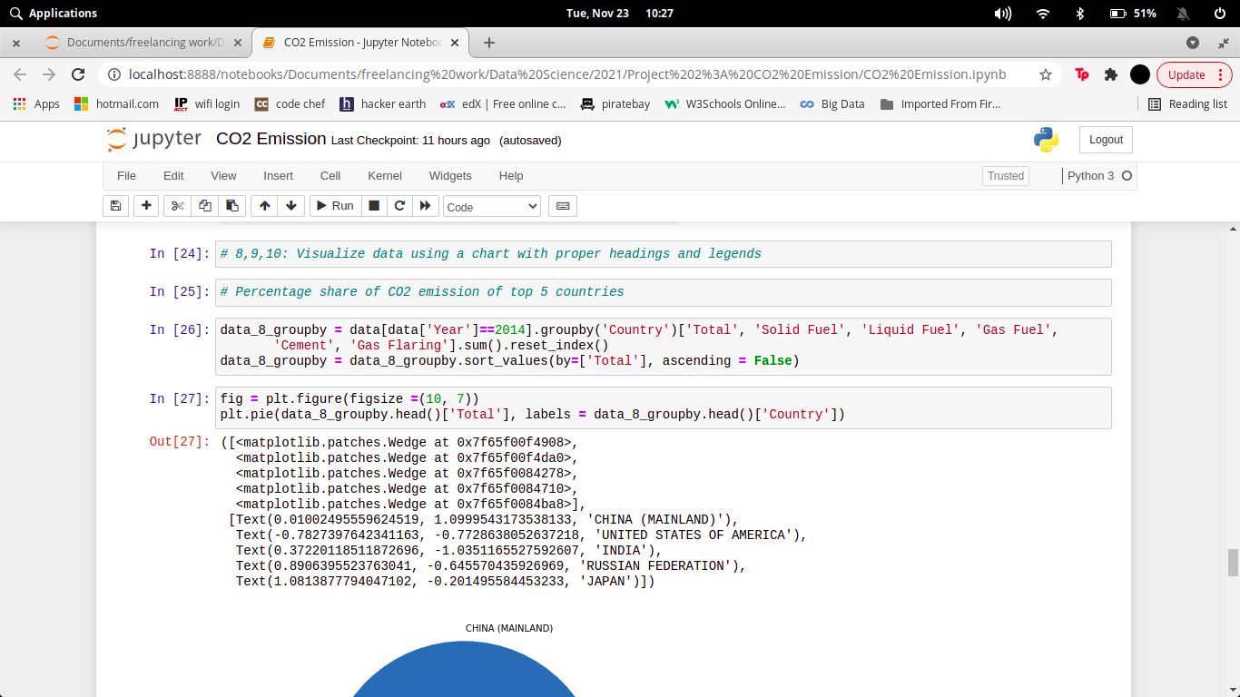

**Output:-**

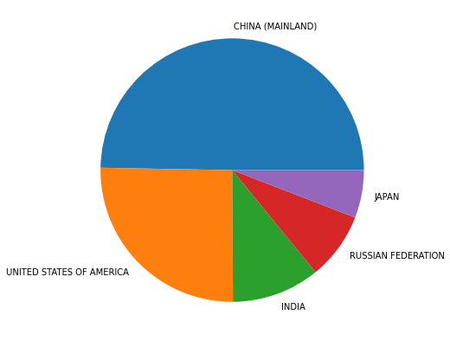

1. **Visualize data of Saudi Arabia on the basis of Year using a chart with proper headings and legends.**

**Code:-**

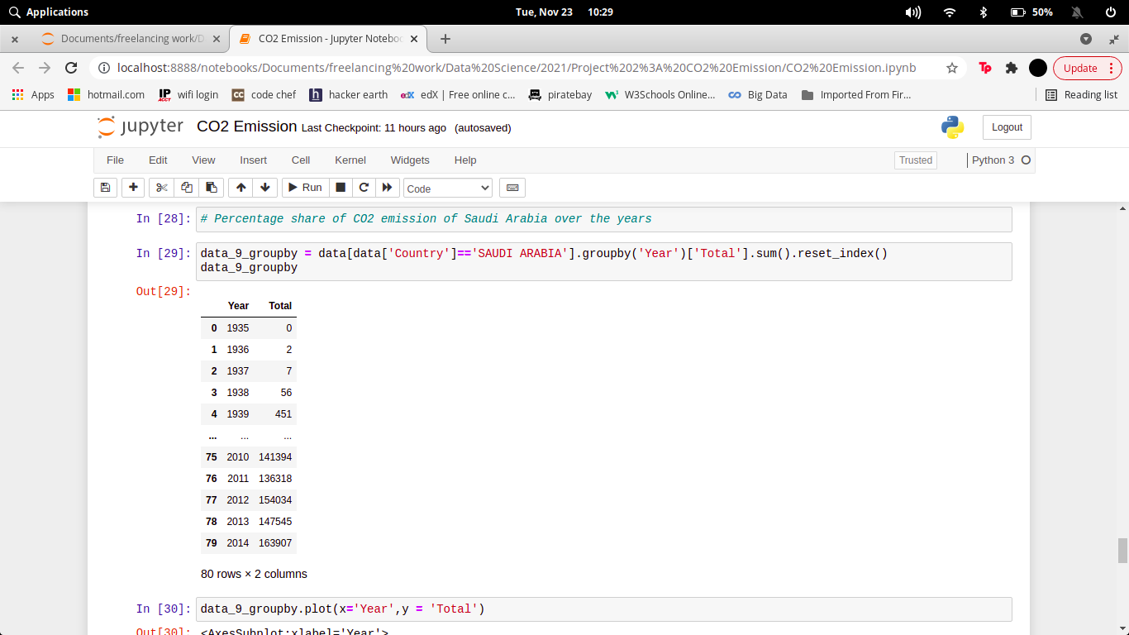

**Output:-**

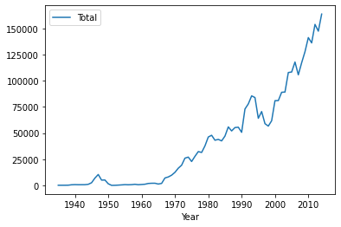

1. **Visualize data of USA on the basis of Year using a chart with proper headings and legends.**

**Code:-**

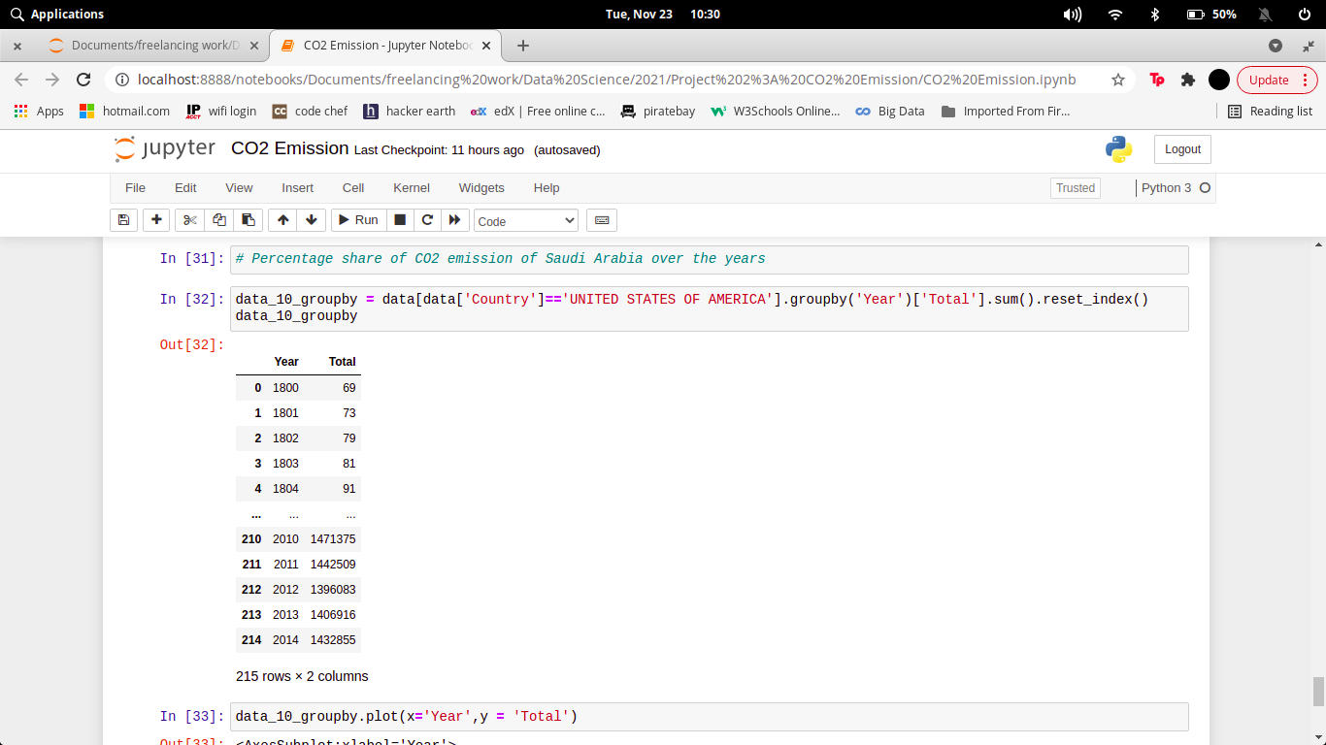

**Output:-**

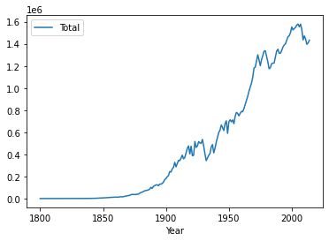

# Executive Summary

**CONCLUSION**

In 2014, the highest dioxide (CO2) emitters were China, the us, the eu Union, India, the Russia, and Japan. These knowledge embrace carbon dioxide emissions from fuel combustion, additionally as cement producing and gas flaring. Together, these sources represent an outsized proportion of total international carbon dioxide emissions.

# References

* https://pandas.pydata.org/docs/
* https://www.kaggle.com/ggsri123/co2-emissions-from-fossil-fuels
* https://www.w3schools.com/python/pandas/pandas_plotting.asp